horizontal line

**Takouba**

Veterans Affairs

Modeling to Learn  
System Dynamics Platform   
(to Increase Timely Access to VHA Evidence-based Outpatient Mental Health Care)

**Design Document -- MTL Version 1.5**

Wednesday, 20 June 2018  
Version 1

horizontal line

# Document History & Status

|  |  |  |
| --- | --- | --- |
| Version | Date | Description/ Status |
| v 1 | 20 June 2018 | Start of Document / Development. |
| v 1 | 27 June 2018 | V 1 Final Draft Released to MTL Team for review, Due Friday 29 June 2018. |
| v 2 | 28 June 2018 | Divided Ver 1.5 into 1.51 (AGG Model Development) and 1.52 Rest of Fixes. |
| v 3 | 29 June 2018 | Incorporated MTL Team comments and released to Development |



**Table of Contents (Quick Link)**

Document History & Status

Objective of This Document

Basics

Objectives

Schedule

Current Vensim Models in Use

Design Features

Save Experiment Slider Settings.

Provide Advanced Chart Management in Drop Down Menus

Provide File Management Functions for Saved Sessions

Provide Bold-face on Lines for Experiment Values Changed from Default

Provide Fields to Gather Metadata and Use to Make Session Name

Provide an Error-proofed Way to Create Session Name

Provide Additional Rules for Team Progress

Provide Ability to Pull-up Non-Arrayed Variables in Models that Use Variable Arrays

Provide Mistake Proofing for Experiment Sliders in PSY Model

Identify the Model Being Used by a Team on Facilitator Dashboard

Expand “i” Information Pop-ups to Include Key Variables in the UI

Provide Bar Charts for Key Data in PSY Model, Experiments Tile, Team Data Data Table

Provide Drop Down Menu for User to Login to an Assigned World

Provide Data Privacy between Teams

Enhance Expanded Outputs Tile

Update AGG Model UI Diagram and Experiments Tile

Testing

Design Questions

Recordings of Calls

Notes on Colors:

1. Most text is in black
2. We can use text color for different indications. For example, Purple is used as notes from designers about questions or items yet to be resolved.
3. Orange is to indicate issues from developers.
4. When questions are acknowledged/resolved we can turn it Black.

# Objective of This Document

1. This document describes the plan to add enhancements and fixes to the Version 1.0 Modeling To Learn simulation.
2. The document is also used to track questions and clarifications during the development and testing phases of the project.

# Basics

## Objectives

The objectives of MTL Ver 1.5 are to provide:

1. Enhanced user functions, such as improved abilities to search, edit, copy and delete saved runs.
2. Enhanced chart functions to the PSY model.
3. Improved intra-team data file privacy.
4. Model diagram and experiment tile fixes to the AGG model.

## Schedule

Below is the schedule for the design and development of MTL Ver 1.5. “NLT” means no later than.

1. Complete Design Document: NLT 27 June 2018
2. Design Document Approved NLT: 29 June 2018
3. Notice to Proceed to Development Team, NLT: 2 July 2018
4. Version 1.51- AGG Model completed in DEV and moved to TEST NLT: 11 July 2018
5. Testing Version 1.51 – AGG Model completed and moved to PROD NLT: 16 July 2018
6. Begin Version 1.52 – Rest of Fixes
7. Release for Team Testing, NLT: 31 July 2018
8. Testing Concluded: NLT 2 August 2018
9. Version 1.52 Release Date: 6 August 2018

## Current Vensim Models in Use

1. The Vensim models and diagram to use for Version 1.5:
   1. CC - cc_v34_2018_06_19_uifreeze
   2. MM - mm_v34_2018_06_15_uifreeze
   3. PSY - psy_v18_2018_06_21_uifreeze (This version on hold until Ventana and Forio determine cause of model failure in Lennox version of Vensim).
   4. AGG - agg_v11_2018_06_25 (This version to be updated NLT 2 July to include variables to support base case values for Appropriate Proportions for Supply variable array).
2. Model Parameters -- As listed in Epicenter Model Directory, Dynamic Data Folder, input-model-parameters-list.csv
   1. Test model parameters file for use with AGG version indicated above will be provide NLT 2 July to support base case values for Appropriate Proportions for Supply variable array.

# Design Features Version 1.51

The sections below describe the design specifications for version 1.51. The objectives for the completion of version 1.51 are:

* Complete AGG model conversion to incorporate new experimental sliders.
* To give users the ability to see their base case values, prior to iterating the simulation
* To give the users the ability to set their experimental values, starting from the values stored from previous runs.
* To improve privacy between teams and improve prior experiment file management.

## Save Experiment Slider Settings.

1. Provide the user with the ability to pull Experiment slider settings from previous runs, from a drop-down menu of previous model runs in the Experiments Tile.
2. When a previous run is selected, a pop-up tile will appear that displays the values of the previous run, and a “go” button.
3. When the user clicks on the “go” button, the experiment sliders in the current session will reset to the values displayed in the pop-up.
4. The users may continue to adjust slider settings.
5. If a previous session is not selected, the session would start with default settings.

Figure 1

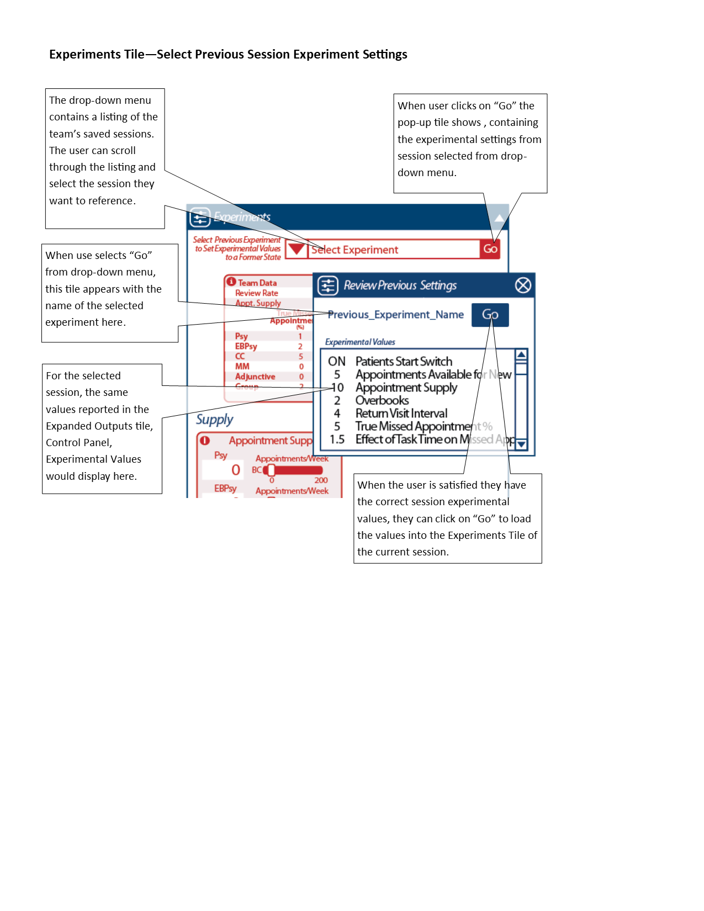

## Update AGG Model UI Diagram and Experiments Tile

Change AGG model UI diagram and make modifications to Experiments Tile (see figures below)

1. General: Any changes in variable naming will be reflected in the chart menus of the Expanded Outputs Tile.
2. Remove:
   1. Upper Leftmost “Team Data” (red, no box), arrow toward “Review Rate” (dark blue), and “Use Team Data for Team Review Rate ON/OFF (red box)
   2. “Referral % for Supply” and the two light blue arrows connected to it
   3. Light blue arrow from “Appropriate Patient Start Rate for Supply “ to “Review Rate”
3. Change:
   1. “Review Rate” -> “Intake Evaluation Rate” (green box with slider)
   2. “Patients Waiting for Treatment Decision” -> “Patients Waiting for Intake Evaluation” (black text, no box)
   3. “Treatment Decision Rate” -> “Intake Completion Rate” (black text, no box)
   4. ”New Patient Wait Time” -> “Intake Evaluation Wait Time” (black text, no box)
   5. “Wait Times Affect New Patient Referrals” -> “Wait Times Affect Intake Evaluations” Feedback Loop (large blue text, no box)
   6. “New Patient Delays Affect Referrals” -> “Start Delays Affect Treatment Decisions"” Feedback Loop (large blue text, no box)
   7. “Effect of Care Delays on Review Rate” -> “Effect of Delays on Intake Evaluation Rate” (purple text, box with slider)
   8. “Referrals Within Team Rate” (red box with slider)-> “Appropriate Service Proportions for Supply” (green box with slider). Move slider down and left, And add an arrow from it toward “Referrals Within Team Rate” dial (positive, light blue)
   9. Extend light blue arrow from “Intake Completion Rate” down to “Referrals Within Team Rate”
   10. Change Dark Blue Large Text in “RVI Affects Referrals” loop to “RVI Delays Affects Treatment Decisions” Feedback Loop.
4. Add:
   1. Review Rate (red box with slider) and arrow toward “Referrals Within Team Rate” (positive, light blue)
   2. Add “Treatment Decision Rate” black text, to flow gauge.
   3. Mode switch icon and experimental slider that will enable the user to select between the “Service Proportion from Team Data” and the “Appropriate Service Proportions for Supply” sliders. When selected, the opposite slider set will be disabled.
5. List of changes for Experiment Tile:
   1. Center justify: Team Data Table
   2. Remove: “Use Team Data for Review Rate”
   3. Add: Intake slider to “Appointment Supply”
   4. Add: “Service Proportions from Team Data” sliders
   5. Add: “Appropriate Service Proportions fro Supply”
   6. Add: “Select Mode” switch to toggle inputs between item d and e above. When one experiment panel is chose, the other does not accept inputs.
   7. Add: Base Case values pop-up. Pop-up must be free floating to allow the user to move the values around for easy reference.
6. See MTL Variable Crosswalk Table google sheet for variable to UI crosswalk. Changed variables are indicated in purple.

Figures 10-11

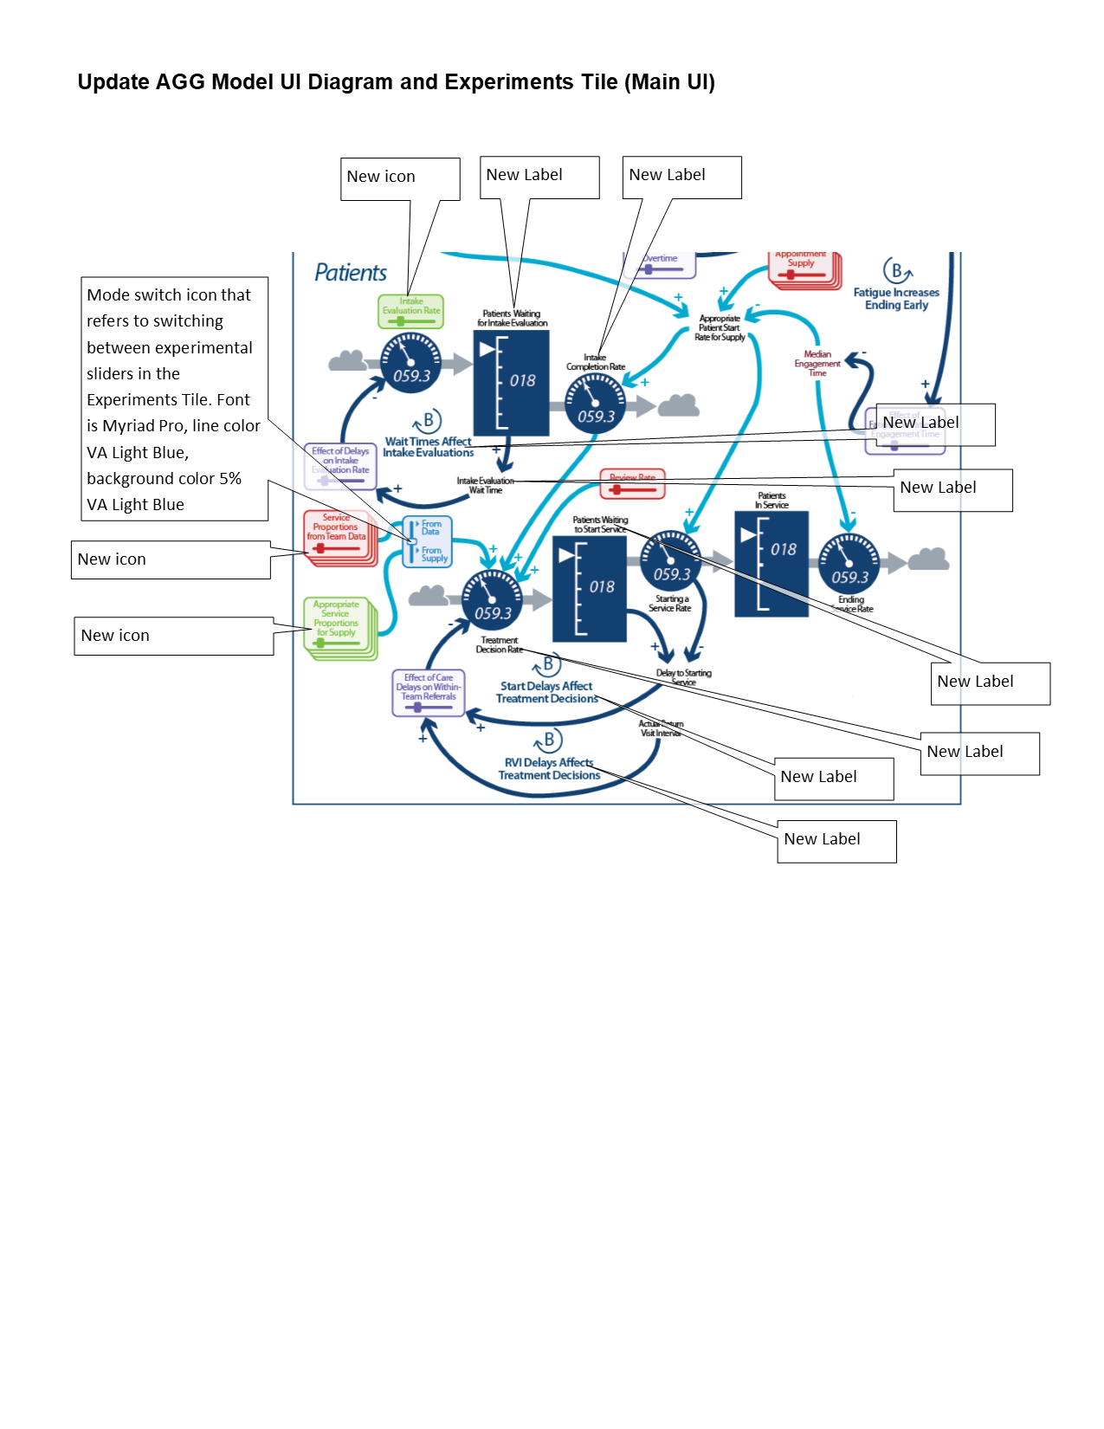

# 

# Design Features Version 1.52

## Provide Advanced Chart Management in Drop Down Menus

Provide advanced file and variable management in the Expanded Outputs Tile, chart selection dropdown menus. Management would include the following functions:

1. Alphanumeric sorting
2. Searching list by typing in partial name of file
3. Naming charts in AGG model, with the service component preceding the variable name
4. Naming charts in MM model, with cohort component preceding the variable name.

## Provide File Management Functions for Saved Experiments

Provide the user, in the Team Lead role, with access to and file maintenance functions of previously saved model runs. Model runs files will be alphabetized. Maintenance functions would include:

1. Searching Files
2. Deleting Files
3. Renaming files.

Figure 2

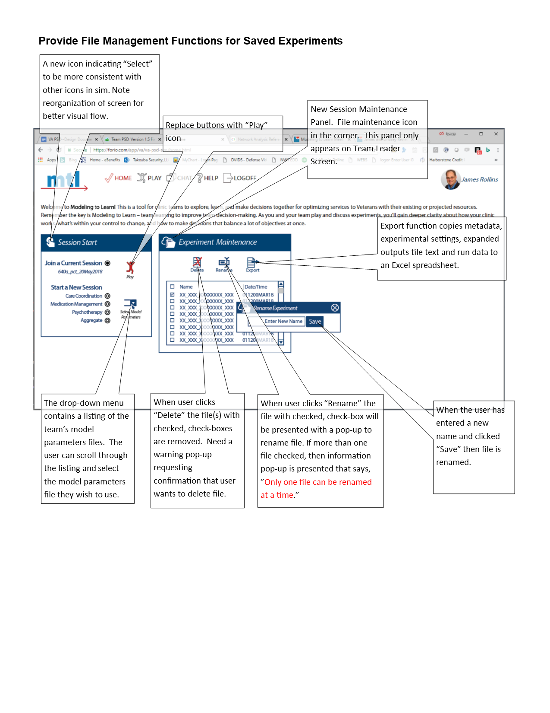

## Provide Bold-face on Lines for Experiment Values Changed from Default

Provide highlighting on lines for experiment values that have been changed from default settings, for experiment values listed in the Current Experiment Values window in the Control Panel of the Expanded Outputs screen.

1. Save these bold-face lines when the run is saved, or saved during reset.
2. Redisplay boldface and highlight when experimental values are recalled from the Experiments Tile, Select Previous Experiment Settings.

Figure 3

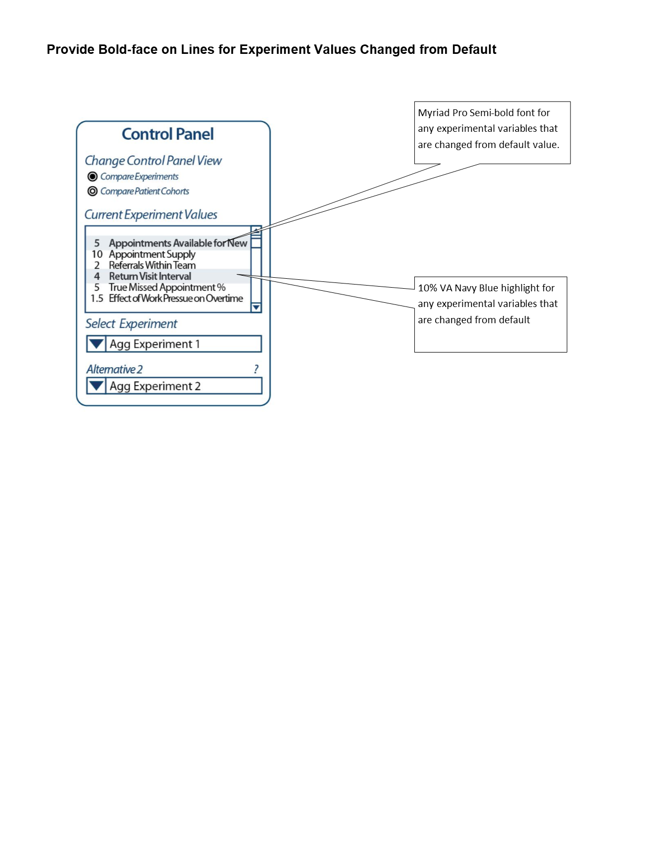

## Provide Fields to Gather Metadata and Use to Make Session Name and Provide an Error-proofed way to Create Experiment Name

In the Expanded Outputs screen, provide fields to gather meta-data for the model run, to aid researchers in the prioritization and search of data. The following will be metadata gathered by the simulation (see figure below for user inputs):

1. Metadata
   1. Vensim Model being Used (provided by system) - CC, MM, PSY or AGG
   2. Last Save Date/Time (provided by system)
   3. Variable, number and units of measure (user selected) - A drop down menu that lists variables in the model, numbers and units. When user clicks “Add” the system truncates inputs and adds to the Experiment Name. The fields are then cleared for additional inputs. The user may add more than one variable name.
   4. Cohort, number and units. Uses same process as outlined in c above.
   5. Service, number and units. Uses the same process as outlined in c above.
   6. For models that do not have “Service” or “Cohort” variable arrays, the drop downs will be grayed out and inactive.
2. How the Experiment Naming Algorithm Works Using Metadata:
   1. User selects Variable. Code will select the first letter of each capitalized word from the variable name. For example, if the variable name is “Appointments Used by Existing Patients” then the program would truncate the name to “AUEP.”
   2. User selects a number, which indicates the value related to the units in the next step. For example, if the user selects “10” then the number would be “10.”
   3. User selects a unit of measure. Examples include % - pct, Patients Per Week—ppw, appointments—apts, and others. In this case, the user selects “appointments” or “apts.”
   4. The system would then produce the Experiment Name, “AUEP_10apts” and so on.
   5. User next selects Cohort information, which uses established codes (PTSD, PSY, EBPSY, and Others). In this example, the user selects “PTSD.”
   6. User selects numbers and units as in 2 and 3 above. In this case, user selects 5 ppw.
   7. The system then adds the cohort values to the variable information, such as “AUEP_10apts_PTSD_5ppw”
   8. The Experiment cannot be saved without at least one variable, number and unit selected. If user fails to select a variable, then a warning pop-up will say, “Please select a variable, number and unit before saving.”

Figure 4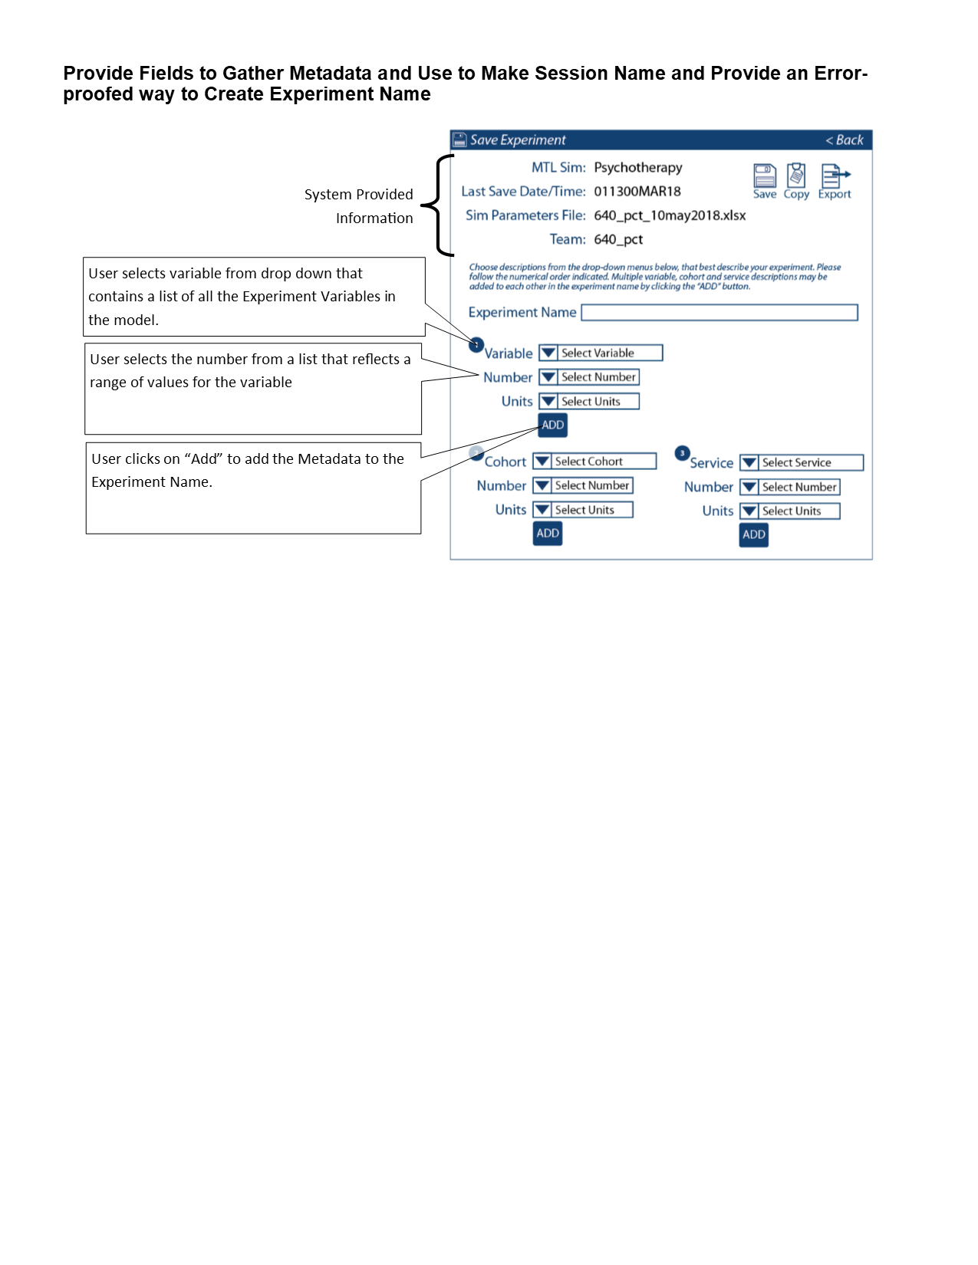

## Provide Additional Rules for Team Progress

Provide rules to more tightly regulate team progress reporting to the Facilitator Dashboard.

1. Require greater than 50 characters per field, in the "Our Question," "Our Hypothesis," "Our Findings" and "Our Decisions" fields, before reporting incremental (20%) progress for each.
2. Before the run can be "Reset," require the user to provide inputs into the "Our Findings" and "Our Decisions" fields.
3. If users do not provide required input, display a pop-up warning that says, “A minimum of 50 characters are required in each of the “Our Question,” Our Hypothesis,”Our Findings” and “Our Decision fields.”

## Provide Ability to Pull-up Non-Arrayed Variables in Models that Use Variable Arrays

Provide the user with the ability to pull up non-arrayed variables in the extended output tile in the MM and AGG models (see Acknowledged Bug 76 in Lean Testing). Right now, the code doesn’t allow for rendering of arrayed variable charts and single variable charts in same model (e.g., we can’t pull up a chart of “Measured versus Actual Time” in the MM model, because that variable isn’t subdivided by diagnostic cohort, it describes an issue affecting the whole team).

## Provide Mistake Proofing for Experiment Sliders in PSY Model

In the Psychotherapy model, Experiments Tile, there are two Experiment Sliders, "New Patients Who Initiate %" and "Initiators Who Complete %." Provide a "pop-up" warning (see figure below), that alerts the user when they enter %'s that sum to more than 100%.

Figure 5

## 

## 

## Identify the Model Being Used by a Team on Facilitator Dashboard

Provide a field under the gauge, in the Facilitator Dashboard, that identifies the type of model the selected team is running (see figure below).

Figure 6

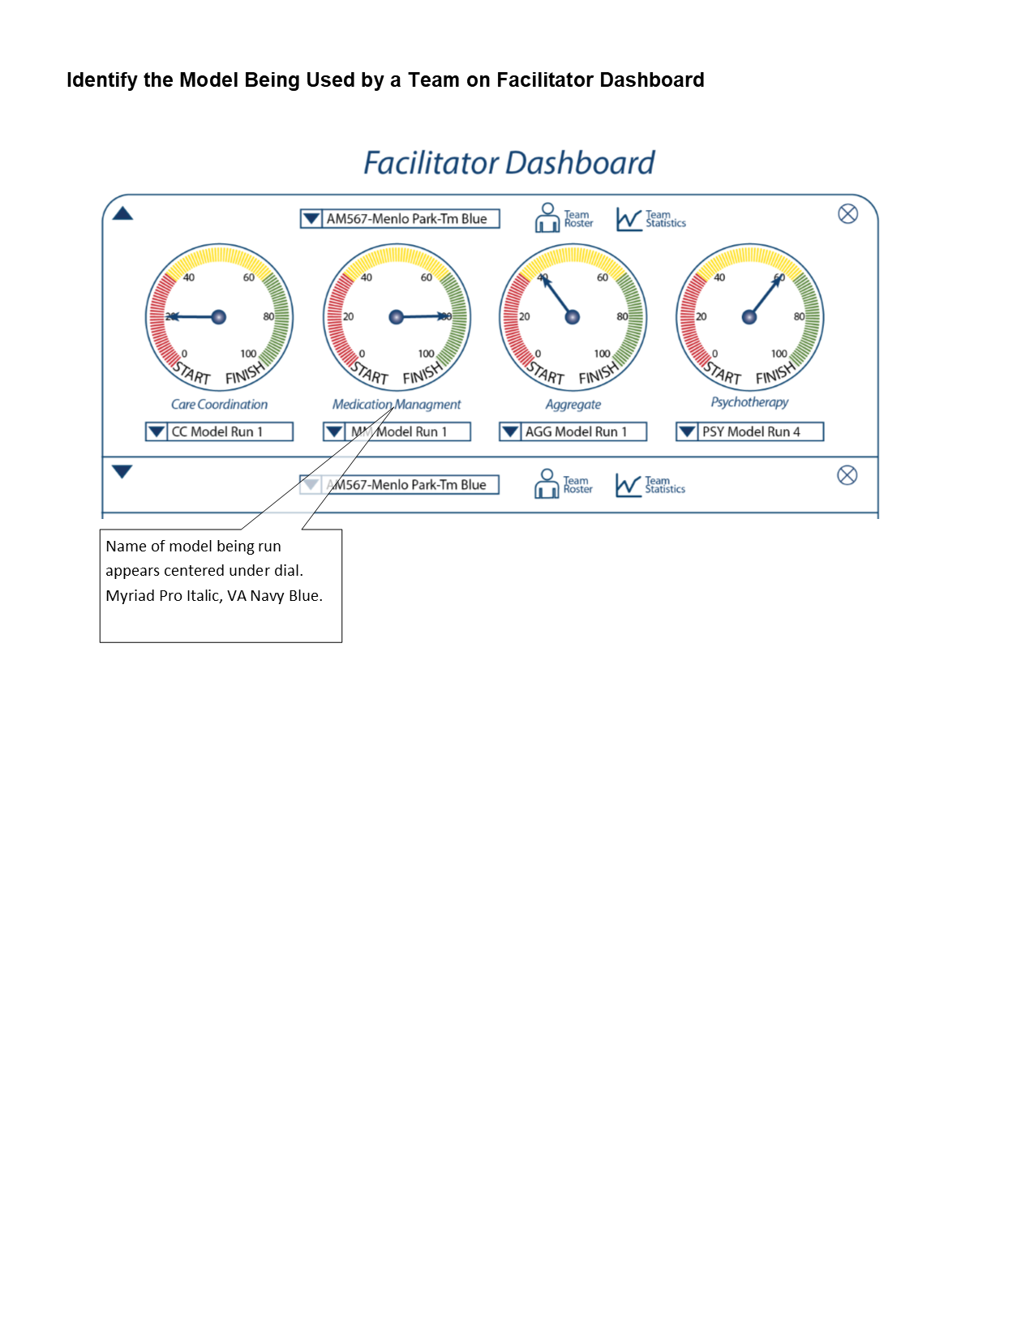

## 

## Expand “i” Information Pop-ups to Include Key Variables in the UI

Provide pop-ups with text provided by team in a comma delimited spreadsheet. Code will refer to a comma delimited sheet **To Be Published** for contents for each Information Pop Up.

1. Comma delimited sheet will provide Administrator with the ability to change the contents of the “i” pop-up tile at any time. Location of the file will be in the Interface directory in the Dynamic Data folder.
2. See figure below for example of how “i” is incorporated into UI.
3. Provide “i” icons for each variable, as illustrated below, for the CC, MM, PSY and AGG model UI.

Figure 7

## 

## Provide Bar Charts for Key Data in PSY Model, Experiments Tile, and Team Data Table

In the Psychotherapy model, Experiments Tile, Team Data Table, provide a pop-up that displays bar-chart data for selected variables (see figures below).

1. Provide bar charts for the "Return Visit Interval after 3 Months (weeks) and "Engagement Time after 3 Months (weeks)" variables.
2. X axis value sets will be "From 1 Visit," "From 2 to 7 Visits,""From 8 or More Visits" variables, divided into "First Quartile." "Mean," and "4th Quartile."
3. If possible, first x-axis value set will be VA Navy Blue, second x-axis value set will be VA Light Blue and third x-axis value set will be VA Vibrant Light Blue.
4. Y axis will be measured in weeks.

Figure 8

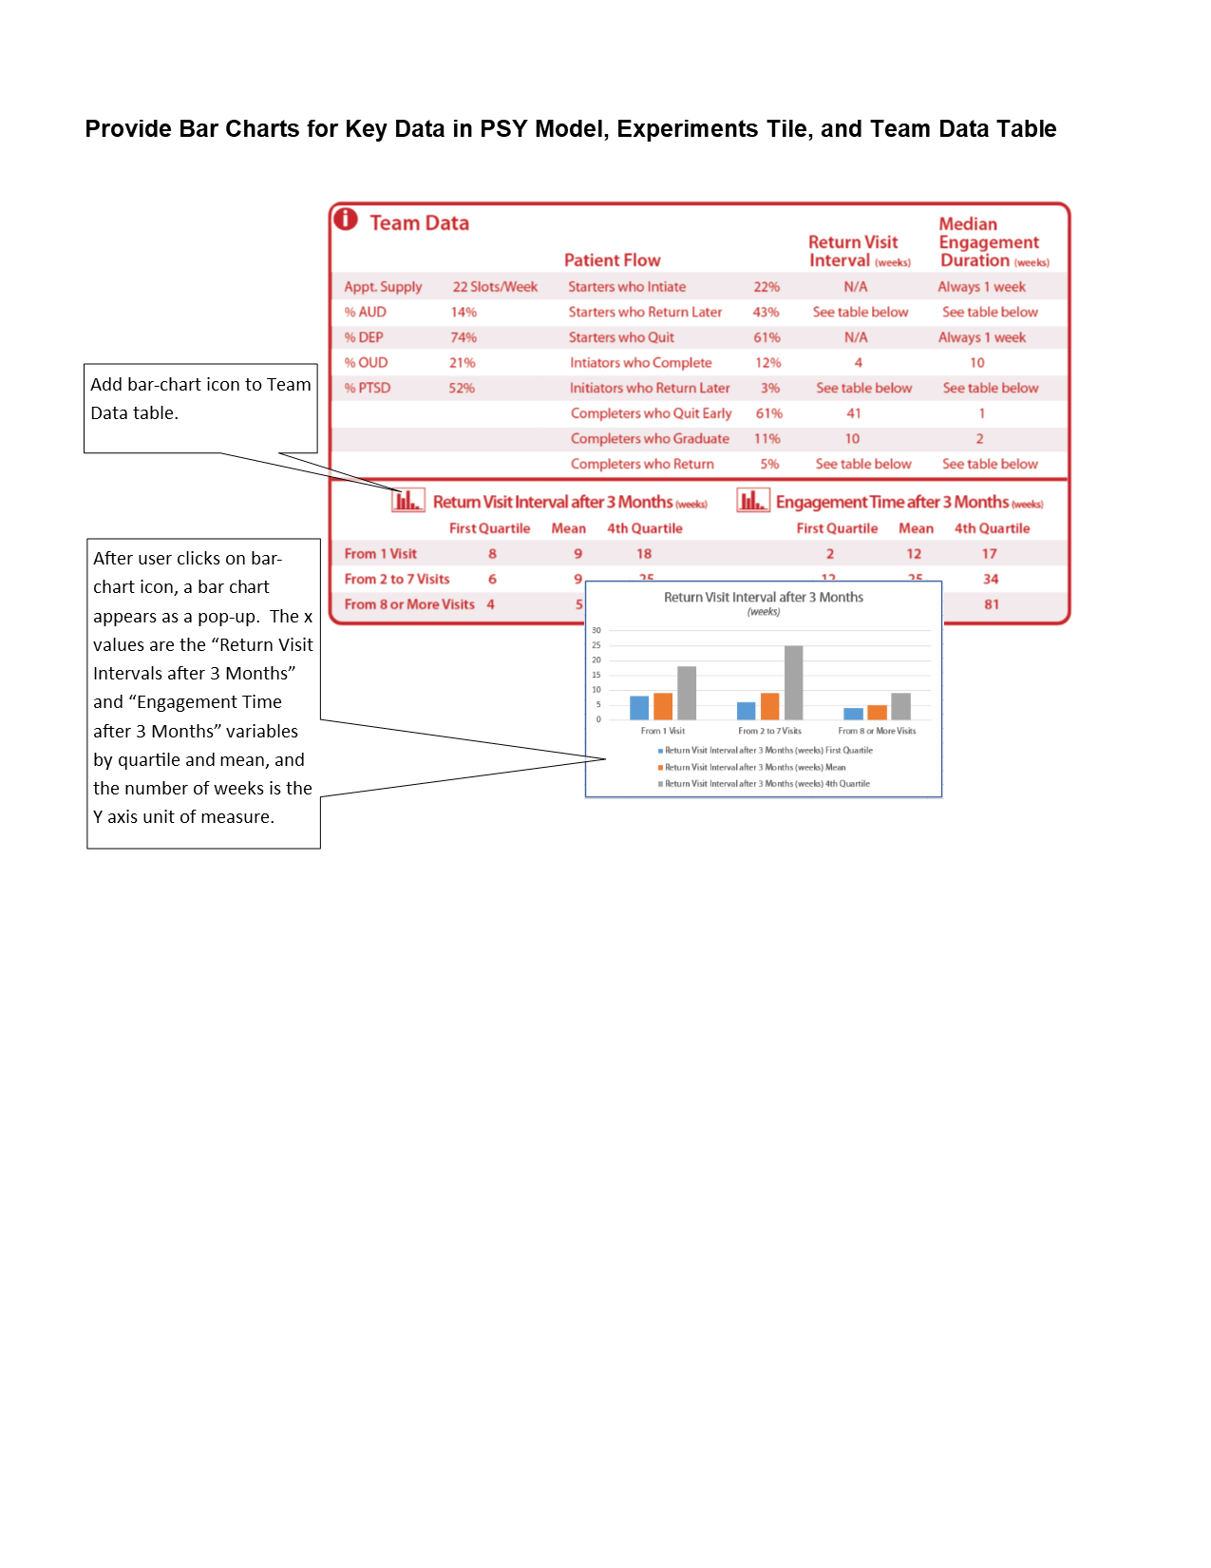

## Provide Drop Down Menu for User to Login to an Assigned World

Provide the user a drop-down menu, in the login dialogue box that allows the user to choose the group they wish to login under. The drop down menu should identify the World by the team name assigned in world-team-mapping.csv in the Model Directory, Dynamic Data folder.

Figure 9

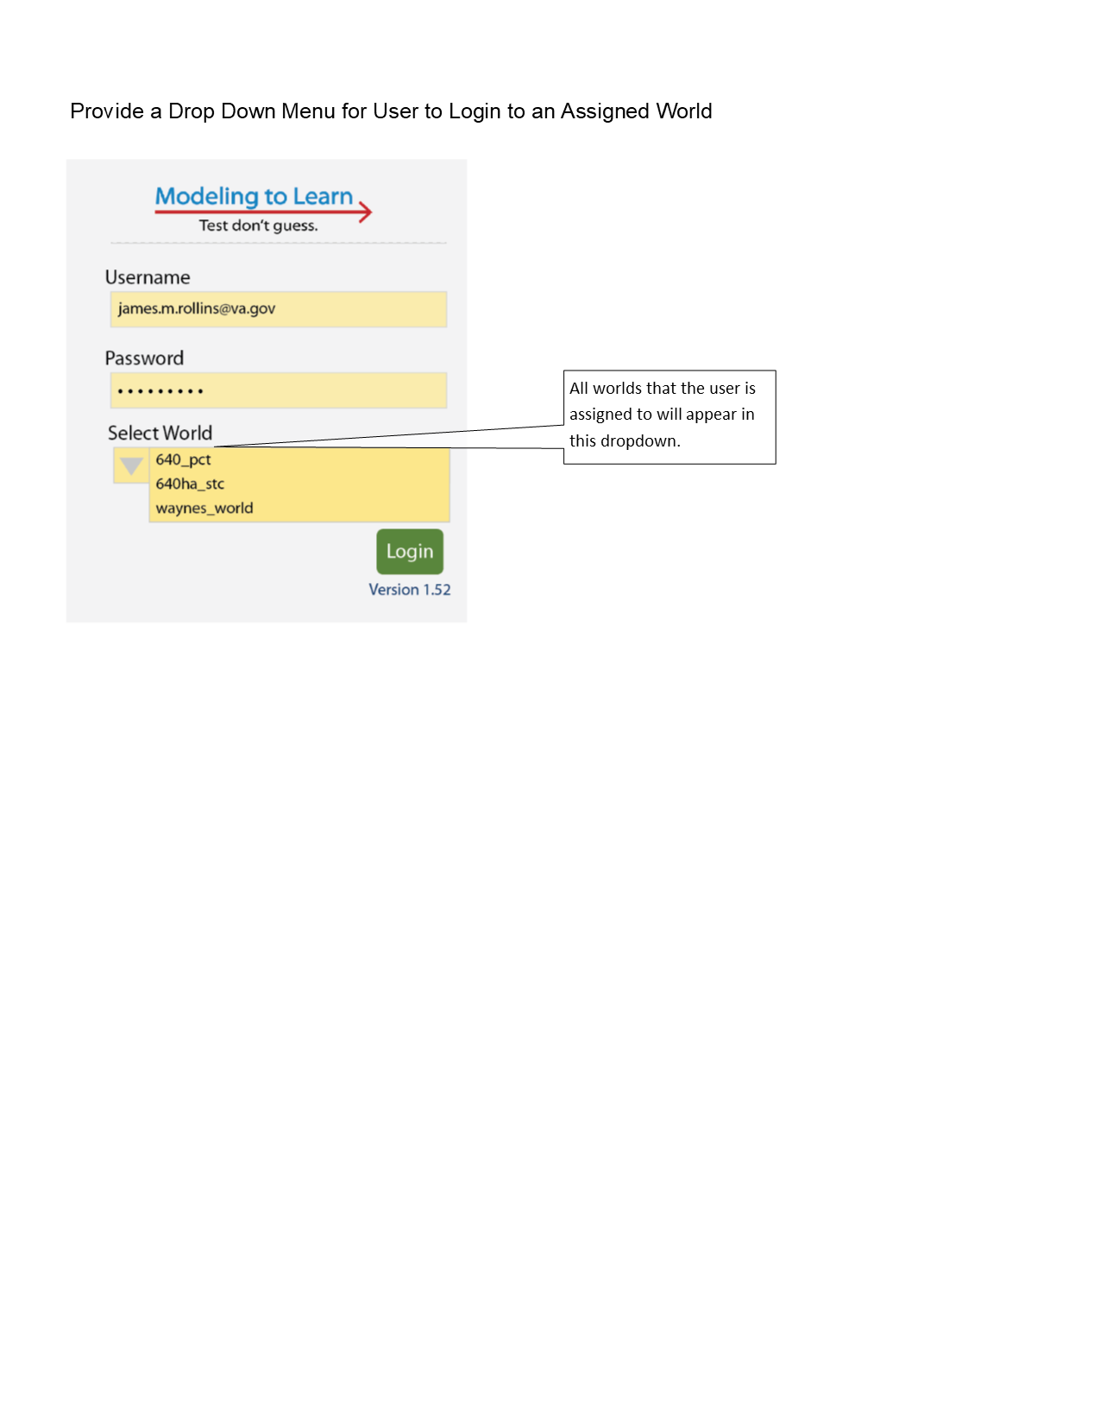

## Provide Data Privacy between Teams

From the Home Page, teams can only select Model Parameters files that are associated with their teams.

1. Create a user interface, so a user with team leader privileges can enter sim parameters file names into the API (versus a csv file) (see figure 10)
2. Store the file names for the team’s drop down menu in Epicenter Data API.
3. When a user with team lead privileges login to their world, the system will store the login to team relationship as a variable, so the appropriate sim parameters files are entered into that team’s sim parameters directory.

Figure 10

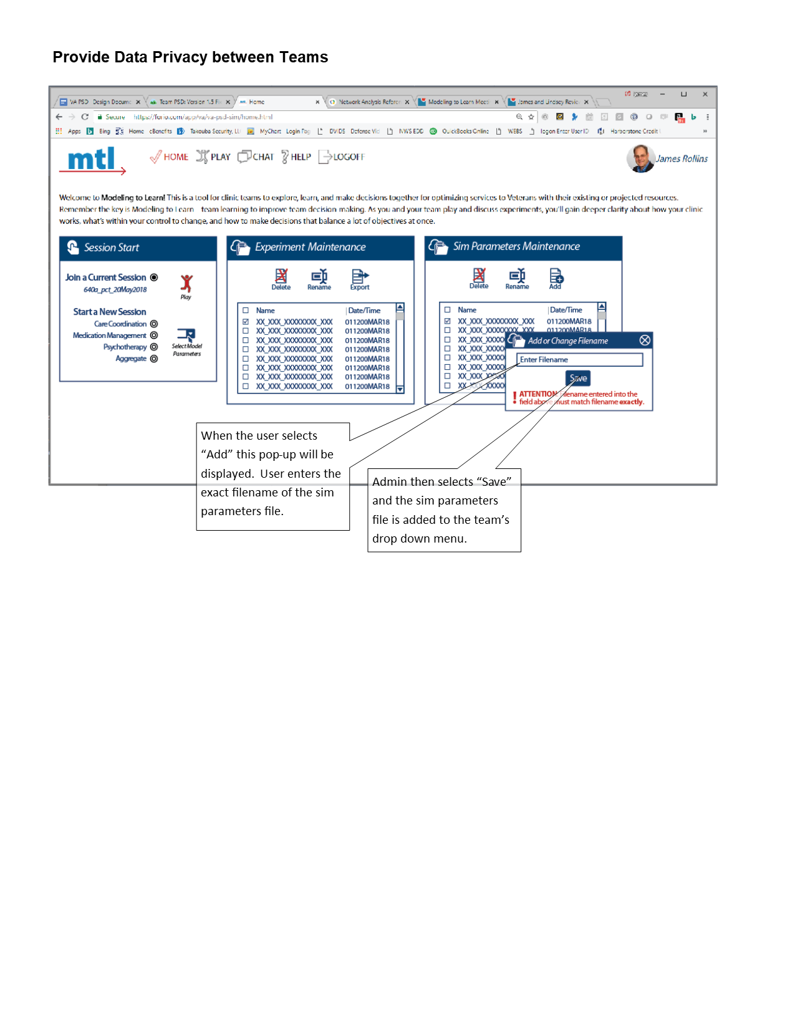

## Enhance Expanded Outputs Tile

For easier reference back to main UI, create an Expanded Outputs tile that can be resized or dragged across the browser window. The resizing functionality must be manually accomplished by the user, by clicking and dragging the window to desired aspect ratio. The tile will only have limited ability to handle reformatting from full-size to tablet-size, with no options in-between.

# Testing

When developers move MTL ver 1.5 from the Development Environment to the Test Environment, testing will be provided prior to release of version 1.5. Testing will ensure the functions are meeting their design specifications. Testing will be conducted by setting up user sessions and following a (test script to be provided when functions enter Beta phase in Test environment). MTL Team support is desired for testing MTL 1.5. Below is the Test Script Listing:

1. Test Script A (TBP)
2. Test Script B (TBP)
3. Test Script C (TBP)

# Design Questions

We can use this section to ask and address questions.

1. Questions for Developers
   1. Where do we store metadata, and how do we recall it? We will store metadata in the API. How to do research and data calls will be determined in a later version. The current metadata will be used to make the filename for the session.
   2. Can we store “i” information dynamically? Yes, we can use a comma delimited file (CSV) to store information for each variables “i” information.
   3. How do we limit the team to be able to only access its own data? See Courses of Action in the Design Features Section. We can support either course of action. Takouba prefers course of action 2, as it starts to get us away from using spreadsheets to manage database functions.
   4. Can the Expanded Outputs Tile be a separate browser page? No. The architecture of Epicenter requires everything occur within the same session.
2. Questions for client.
   1. What is the session naming convention?
      1. Naming Convention Rule: variable_diagcohort_#units; new experiment always added to left
      2. Example:
         1. ref_oud_4ppw
         2. rvi_sail_allocx_oud_40pct_other_40pct_ref_oud_opt5ppw
   2. How do we want to store/retrieve metadata?
   3. We will currently use metadata to build experiment names for easy reference. However, future possibilities for metadata to enhance research include:
      1. Investigating how SD models are used as an intervention
      2. Track experimental input values mapped to qualitative expanded output tile to look at improvement over time
      3. Tracking for alignment to fidelity and learning objectives for CEU's, looking at ST skills
      4. Tracking how sessions went for use
   4. Which variables in the UI do we want to add “i” pop-ups? (recommend in the variable crosswalk table). All variables will have “i” information pop-ups.
   5. Does the client desire to still require data inputs to the Expanded Outputs Screen, “Our Question” and others text fields, before allowing user to reset? Perhaps a warning would be better; Thus, a session that they don’t desire to change or save, could be simply thrown away.

# Recordings of Calls

Call-in URL: (641) 715-0632 / Passcode: 908-483 / <https://www.freeconferencecall.com/join/hcp_meetwithme>

Call-in URL: (712) 451-0889/passcode: 110492/james_m_rollins

join.freeconferencecall.com/james_m_rollins

1. 6/20/2018 - Development and Design Meeting, James and Kunal, <https://fccdl.in/as1jlGV0i3>